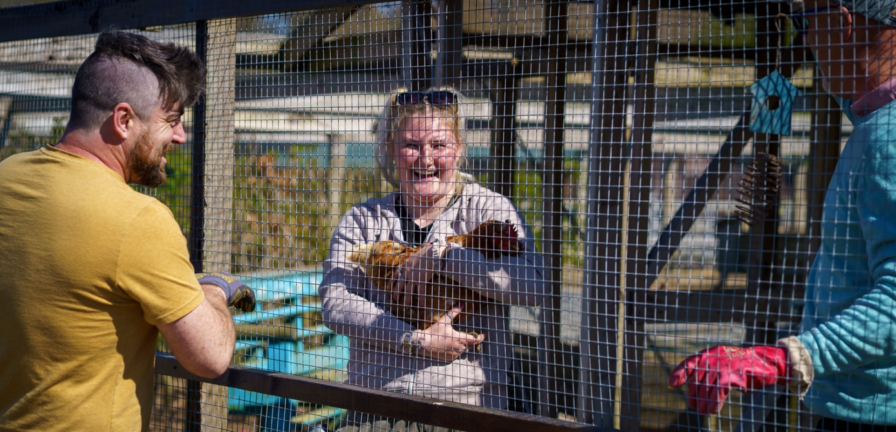

Position available

﻿ We are looking for experience of working with people of all ages who live with a variety of emotional, physical and/or mental barriers. The role will require leadership but teamwork and in-depth knowledge of and expertise in safeguarding is essential. Supporting farm workers (service users) with setting personal goals, data collection and monitoring individual goals will also be a highly important aspect of the role.

Pathways is wholly committed to inclusion and diversity and to building a culture and environment where everyone is appreciated for the unique person they are. We warmly welcome applications from a diverse range of backgrounds and experiences.

Job title: Farm Worker Lead
Salary £15.65 per hour, 20 hours per week, Monday to Friday (9.30 till 13.30) potentially rising to 30 hours per week (equivalent £1356 per month).
Main duties/responsibilities:
• To work collaboratively and proactively alongside the Director, Core team and other staff and volunteers to monitor and manage the farm worker’s journey.
• Lead on the monitoring, management and daily wellbeing of each farm worker.
• Establish constructive, positive and professional relationships with farm workers, Pathways’ staff and volunteers, social workers and farm worker’s families or carers.
• Prioritise the mental health and wellbeing of all farm workers and collate, organise and track strategies for progress towards goals.
• Use data to track, intervene and improve the farm worker’s journey towards overcoming barriers and achieving goals.
• Maintain a visible, supportive and dynamic presence around the farm.

For more information please contact:
Mandy Lyons, Operations Manager, Pathways, Leonard Drive, Lowestoft NR32 4WB
Or call 01502 219064

